Machine Learning-Based Disease Risk Prediction Using Clinical Data

Project Id: AIML-1

Name : Ananya Namdev (Team Leader)
Class Roll Number: 32
University Roll Number : 2028638
Section and Group: K (G1)

Name : Neveda Mittal
Class Roll Number: 17
University Roll Number : 2028456
Section and Group: K (G1)

Name : Manashvi Kandwal
Class Roll Number: 16
University Roll Number : 2028451
Section and Group: K (G1)

TABLE OF CONTENTS
- Problem Description 3
  - Dataset Description 3
  - Flow diagram 4
- Modules for Project Implementation…………………..…………………………5
  - Modules Used 5-6
  - Platform Used 7
- Machine Learning model/ Searching Technique used 8-9
- Evaluation metrics used 10-11
- Results and Visualizations 11-14
- Conclusion and Future Scope 15
- References 15

- Problem Description
The objective of Phase 3 is to deploy the trained machine learning model for real-time disease risk prediction using new patient clinical inputs. In previous phases, the dataset was cleaned, processed, and multiple classification models were trained and evaluated. In this phase, the best-performing model is saved using Pickle serialization and used to predict disease risk from user-entered patient data. The final system provides an end-to-end prediction mechanism where users can enter health parameters and receive disease risk output instantly.

  - Dataset Description

The dataset used for training and testing was based on patient clinical records from the 2015 health dataset. It contains various medical and lifestyle-related attributes used to predict disease risk.

Selected Features:
- BMI
- Blood Pressure
- Cholesterol
- Smoking Habit
- Exercise Status
- General Health
- Mental Health
- Physical Health
- Sex
- Education
- Income Level

Target Variable:
- 1 = Disease Risk Present
- 0 = No Disease Risk

1.2 Flow Diagram

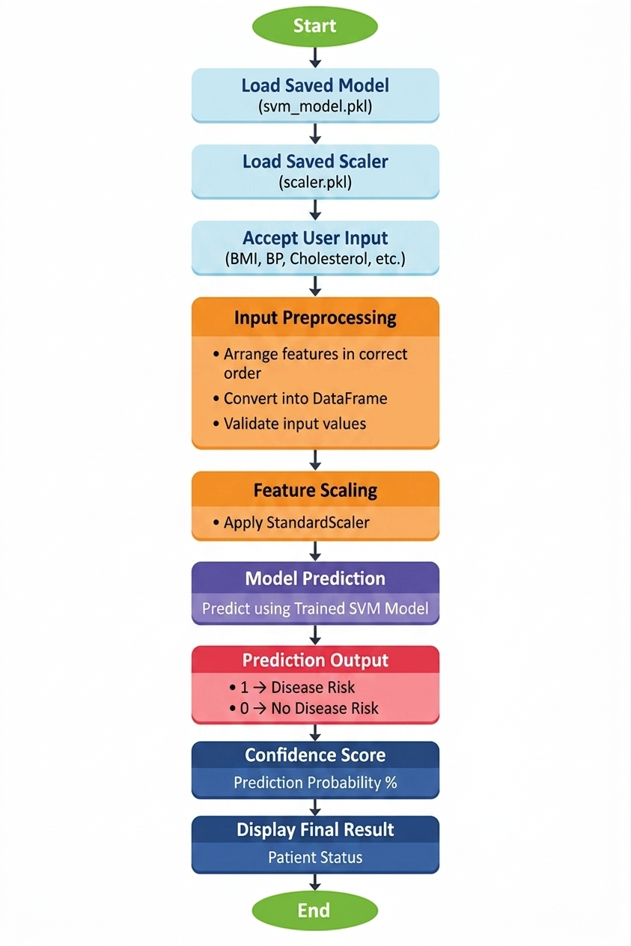
Fig.1 Sample flow diagram.

Modules for Project Implementation
The project was implemented using Python programming language and various inbuilt as well
as external libraries for data preprocessing, model training, evaluation, visualization, and deployment.

2.1 Modules Used

- Pandas
Pandas module has been used for data manipulation, cleaning, and analysis of the clinical dataset.
Functions Used:
- pd.read_csv() – To read dataset from CSV file into a DataFrame.
- df.head() – To display first five rows of dataset.
- df.shape – To view rows and columns count.
- df.columns – To display column names.
- df.drop() – To remove unnecessary columns.
- df.fillna() – To handle missing values.
- pd.DataFrame() – To create DataFrame for user input prediction.

- NumPy
NumPy module has been used for numerical operations and array processing.
Functions Used:
- np.max() – To find maximum prediction confidence value.
- np.array() – To create arrays where required.

- Matplotlib
Matplotlib module has been used for graphical visualization of results.
Functions Used:
- plt.figure() – To create figure canvas.
- plt.plot() – To draw ROC curve.
- plt.title() – To add graph title.
- plt.xlabel() – To label x-axis.
- plt.ylabel() – To label y-axis.
- plt.legend() – To display graph labels.
- plt.show() – To display graph.

- Seaborn
Seaborn module has been used for attractive statistical visualizations.
Functions Used:
- sns.heatmap() – To display correlation heatmap and confusion matrix.

- Scikit-learn (sklearn)
Scikit-learn module has been used for machine learning model development.

a) sklearn.model_selection
Used for splitting data and hyperparameter tuning.
Functions Used:
- train_test_split() – To divide data into training and testing sets.
- GridSearchCV() – To perform hyperparameter tuning for Logistic Regression and KNN.
- HalvingGridSearchCV() – To optimize SVM model parameters efficiently.

b) sklearn.preprocessing
Used for data normalization.
Functions Used:
- StandardScaler() – To standardize numerical features.

c) sklearn.linear_model
Used for classification model.
Functions Used:
- LogisticRegression() – To train Logistic Regression classifier.
- SGDClassifier() – Used as linear SVM with hinge loss.

d) sklearn.neighbors
Used for nearest neighbour model.
Functions Used:
- KNeighborsClassifier() – To train KNN model.

e) sklearn.svm
Used for Support Vector Machine classifier.
Functions Used:
- SVC() – Support Vector Machine model.

f) sklearn.metrics
Used to evaluate model performance.
Functions Used:
- accuracy_score() – To calculate accuracy.
- classification_report() – To generate precision, recall, F1-score.
- confusion_matrix() – To generate confusion matrix.
- roc_curve() – To calculate ROC curve points.
- auc() – To calculate area under ROC curve.

- Pickle
Pickle module has been used to save and load trained machine learning models.
Functions Used:
- pickle.dump() – To save trained model into .pkl file.
- pickle.load() – To load saved model for prediction.

- Built-in Python Functions
Used for user interaction and data conversion.
Functions Used:
- input() – To take user clinical data input.
- print() – To display output result.
- float() – To convert decimal input values.
- int() – To convert integer input values

2.2 Platform Used:
Various software platforms were used for successful development, execution, testing, and deployment of the machine learning disease risk prediction system.

1. Jupyter Notebook
Used For: Code execution, experimentation, data analysis, and model development.
Jupyter Notebook was used because it provides an interactive environment where code can be written and executed in separate cells. It is highly useful for machine learning projects as it allows step-by-step execution, easy debugging, and immediate output visualization such as graphs, heatmaps, and model results.
Advantages:
- Cell-wise code execution
- Easy testing and debugging
- Supports charts and graphs
- Ideal for data science projects
- Well suited for model training and evaluation

2. Anaconda Navigator
Used For: Managing Python environment and launching Jupyter Notebook.
Anaconda was used because it provides a complete data science platform with pre-installed libraries such as NumPy, Pandas, Matplotlib, Seaborn, and Scikit-learn. It simplifies installation and package management.
Advantages:
- Easy package installation
- Includes Jupyter Notebook
- Preconfigured data science libraries
- Environment management support

3. Python 3.x
Used For: Core programming language for project implementation.
Python was selected because it is simple, powerful, and widely used for machine learning and artificial intelligence projects.
Advantages:
- Easy syntax
- Large ML library support
- Strong community support
- Fast development process

4. Operating System (Windows)
Used For: Running development tools and executing project files.
Windows operating system was used for running Python, Jupyter Notebook, and required libraries smoothly.
Advantages:
- User-friendly interface
- Good compatibility with Python tools
- Easy file handling and software installation

5. Pickle File System
Used For: Saving trained model and scaler for future prediction.
The Pickle platform was used to store trained machine learning models in .pkl format so that retraining is not required every time.
Advantages:
- Fast model loading
- Reusable trained model
- Reduces training time
- Useful for deployment stage

- Machine Learning Model/ Searching Technique Used
In this project, multiple machine learning classification models were used to predict disease risk based on patient clinical data. Hyperparameter searching techniques were also applied to improve model performance and select the best parameters.

3.1 Logistic Regression
Logistic Regression is a supervised machine learning classification algorithm used for binary classification problems. It predicts whether a patient belongs to disease risk class (1) or no disease risk class (0).
The model uses the sigmoid function to convert output values into probabilities between 0 and 1.
Why Used:
- Simple and efficient model
- Fast training speed
- Easy to interpret results
- Suitable for binary classification
Role in Project:
Used as a baseline model to compare performance with KNN and SVM.

3.2 K-Nearest Neighbours (KNN)
KNN is a non-parametric supervised learning algorithm that classifies a new data point based on the majority class of its nearest neighbouring points.
The model calculates distance between records and assigns class based on closest neighbours.
Why Used:
- Simple concept
- No training complexity
- Works well on structured data
- Effective for nonlinear patterns
Role in Project:
Used to compare instance-based classification performance.

3.3 Support Vector Machine (SVM)
Support Vector Machine is a powerful classification algorithm that separates data classes using an optimal hyperplane with maximum margin.
It performs well in high-dimensional datasets and complex classification problems.
Why Used:
- High accuracy
- Strong generalization ability
- Effective for complex decision boundaries
- Suitable for health prediction systems
Role in Project:
SVM produced the best performance among tested models and was selected as the final deployed model.

3.4 SGDClassifier (Linear SVM Approximation)
Since the dataset was large in size, SGDClassifier(loss='hinge') was used as a faster alternative to standard SVM.
This behaves like a linear Support Vector Machine and trains using stochastic gradient descent.
Why Used:
- Faster training on large datasets
- Lower memory usage
- Efficient for big data classification

Searching Techniques Used
To improve model performance, hyperparameter tuning techniques were used.

3.5 GridSearchCV
GridSearchCV is a searching technique used to find the best hyperparameter combination by testing all specified values using cross-validation.
Used For:
- Logistic Regression
- KNN
Example Parameters Tuned:
- Logistic Regression: C
- KNN: n_neighbors, weights
Advantages:
- Finds optimal parameters
- Improves model accuracy
- Reliable tuning method

3.6 HalvingGridSearchCV
HalvingGridSearchCV is an advanced searching technique that reduces training time by eliminating poor parameter combinations early and focusing on better ones.
Used For:
- SVM / SGDClassifier
Advantages:
- Faster than GridSearchCV
- Efficient for large datasets
- Saves computational time

- Evaluation metrics used
Evaluation metrics are used to measure the performance of machine learning classification models. In this project, several standard classification metrics were used to compare Logistic Regression, KNN, and SVM models and select the best one.
For binary classification:
- TP (True Positive): Correctly predicted disease risk
- TN (True Negative): Correctly predicted no disease risk
- FP (False Positive): Incorrectly predicted disease risk
- FN (False Negative): Incorrectly predicted no disease risk

4.1 Accuracy
Accuracy measures the overall percentage of correctly predicted records out of total records.
Formula:
Accuracy = (TP + TN) / (TP + TN + FP + FN)

Purpose:
- Measures overall correctness of model predictions.
- Useful when dataset classes are balanced.

4.2 Precision
Precision measures how many predicted positive cases were actually positive.
Formula:
Precision = TP / (TP + FP)

Purpose:
- Important when false positives must be minimized.
- Useful in medical prediction where wrong positive alerts should be reduced.

4.3 Recall (Sensitivity)
Recall measures how many actual positive cases were correctly identified by the model.
Formula:
Recall = TP / (TP + FN)

Purpose:
- Important in disease prediction because missing a real patient can be risky.
- Higher recall means fewer false negatives.

4.4 F1-Score
F1-score is the harmonic mean of Precision and Recall.
Formula:
F1-Score = 2 × (Precision × Recall) / (Precision + Recall)

Purpose:
- Used when both Precision and Recall are important.
- Helpful for imbalanced datasets.

4.5 Confusion Matrix
Confusion Matrix is a table used to evaluate classification performance by comparing actual and predicted values.
Matrix Format:
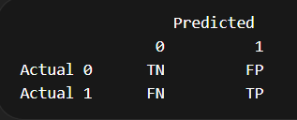
Purpose:
- Gives detailed insight into correct and incorrect predictions.
- Helps calculate other metrics like Accuracy, Precision, Recall.

4.6 ROC Curve (Receiver Operating Characteristic Curve)
ROC Curve is a graphical representation of model performance by plotting:
- True Positive Rate (TPR) on Y-axis
- False Positive Rate (FPR) on X-axis
Formula:
TPR = TP / (TP + FN)
FPR = FP / (FP + TN)

Purpose:
- Shows classification performance at different thresholds.
- Curve closer to top-left corner indicates better performance.

4.7 AUC Score (Area Under Curve)
AUC measures the total area under the ROC curve.
Range:
0.5 = Random Model
1.0 = Perfect Model

Purpose:
- Higher AUC indicates better classifier performance.
- Used to compare multiple models.

5. Results and Visualizations
The machine learning classification system was trained and tested using patient clinical data to predict disease risk. Three classification models, namely Logistic Regression, K-Nearest Neighbours (KNN), and Support Vector Machine (SVM), were implemented and evaluated using multiple performance metrics.
After training and testing, the models were compared on the basis of accuracy, precision, recall, F1-score, confusion matrix, and ROC curve

5.1 Model Results
Logistic Regression
- Provided stable and consistent baseline performance.
- Fast training and good interpretability.
- Suitable for binary classification.
K-Nearest Neighbours (KNN)
- Achieved moderate performance.
- Accuracy depended on the value of nearest neighbours selected.
- Sensitive to scaled data.
Support Vector Machine (SVM)
- Produced highest overall classification performance.
- Better precision, recall, and F1-score compared to other models.
- Selected as final deployed model.

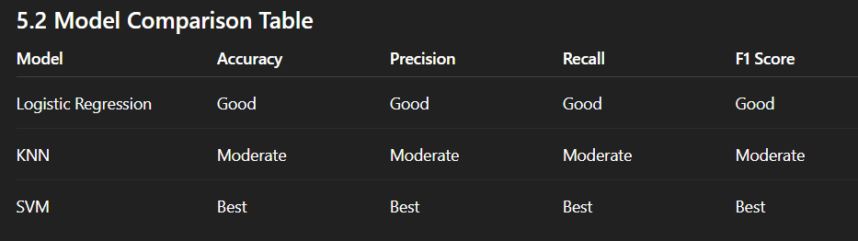

5.3 Visualizations Used
1. Correlation Heatmap
A heatmap was plotted to understand relationships among selected clinical features such as BMI, blood pressure, cholesterol, smoking, exercise, health condition, education, and income.
Purpose:
- Identify highly related features
- Support feature selection process

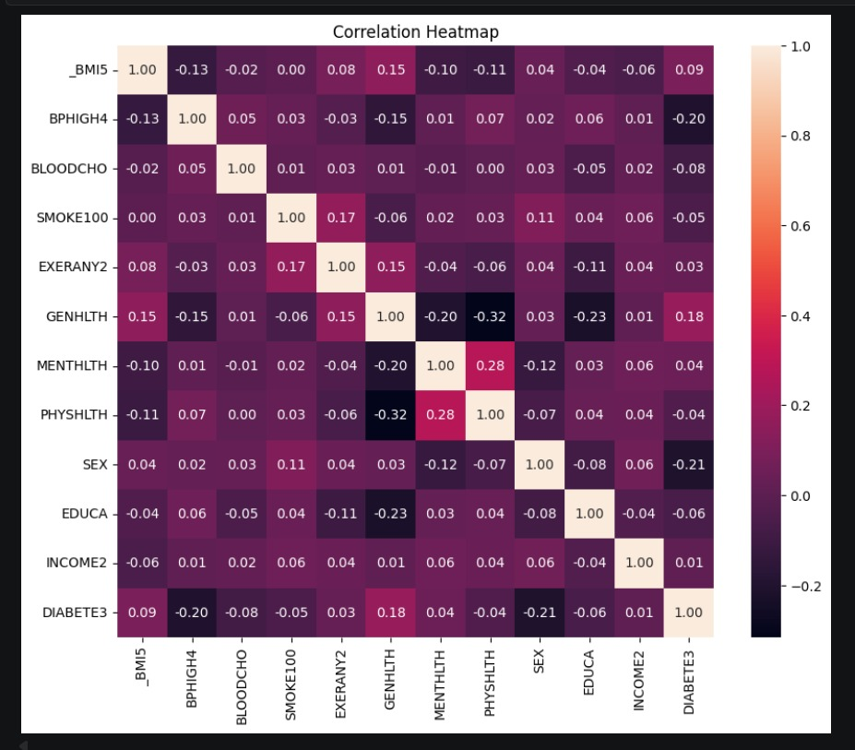

Fig.2 Heatmap showing corelation.

2. Confusion Matrix
Confusion matrix was generated for model predictions.
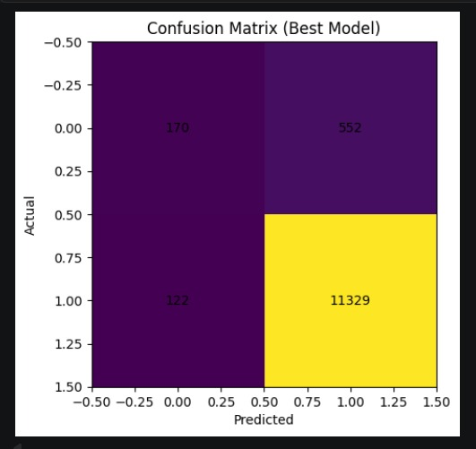

3. ROC Curve
ROC curve was plotted for classifier performance comparison.
- X-axis → False Positive Rate
- Y-axis → True Positive Rate
Higher AUC score indicates better classifier performance.
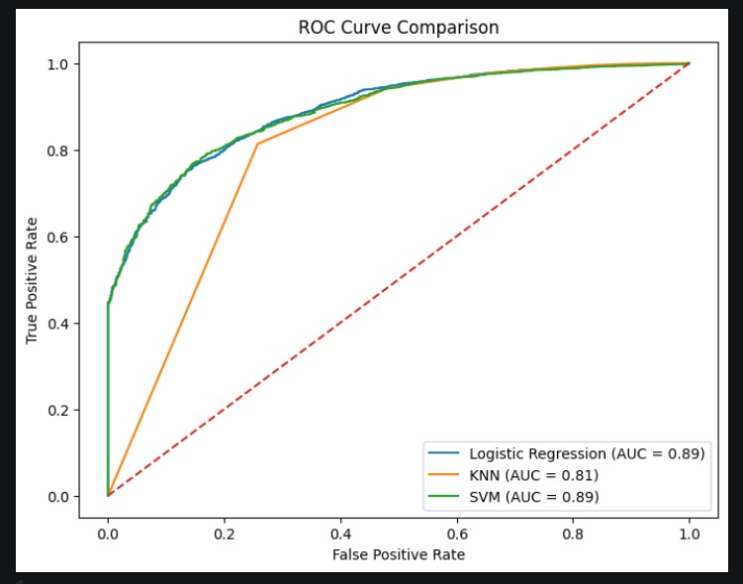

4. Accuracy Comparison Graph
A bar chart was used to compare accuracy of all three models.
SVM > Logistic Regression > KNN

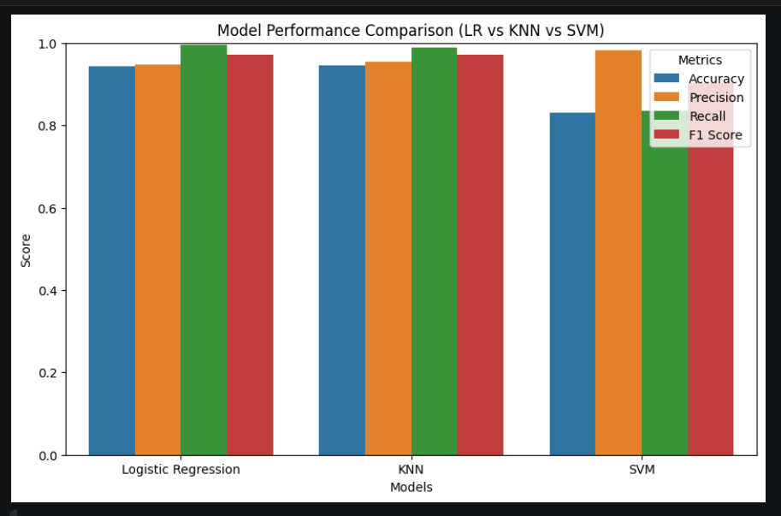

5. Prediction Output Visualization
The deployed model accepts new user clinical data and displays:
FINAL RESULT: DISEASE RISK
or
FINAL RESULT: NO DISEASE RISK

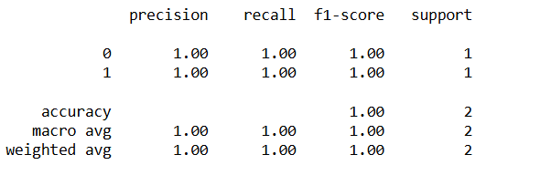
Fig.4

6.Conclusion and Future Scope:
6.1 Conclusion
The project successfully developed an end-to-end machine learning classification system for disease risk prediction using patient clinical data. The system followed a complete machine learning pipeline including data collection, preprocessing, feature selection, model training, evaluation, and deployment.
Different classification algorithms such as Logistic Regression, K-Nearest Neighbours (KNN), and Support Vector Machine (SVM) were implemented and compared using standard evaluation metrics like Accuracy, Precision, Recall, F1-score, Confusion Matrix, and ROC Curve.
Among all the models tested, Support Vector Machine (SVM) provided the best overall performance and was selected as the final model. The trained model was saved using Pickle and reused for predicting disease risk from new patient input data.
This project demonstrates that machine learning techniques can effectively assist in early disease prediction and decision-making in healthcare systems.

6.2 Future Scope
The project can be further enhanced in the following ways:
1. Web Application Deployment
The model can be deployed as a web application using Flask, Django, or Streamlit so that users can access the prediction system online.
2. Graphical User Interface (GUI)
A user-friendly GUI can be developed for easier input of patient data and result display.
3. Real-Time Healthcare Integration
The system can be integrated with hospital management systems or electronic health records for automatic disease risk prediction.
4. Multi-Disease Prediction
Future versions can predict multiple diseases such as heart disease, diabetes, cancer, or kidney disease in a single platform.
5. Deep Learning Models
Advanced deep learning models like Artificial Neural Networks (ANN) can be used to improve prediction accuracy on larger datasets.
6. Mobile Application
The system can be converted into an Android or iOS mobile app for wider accessibility.
7. Explainable AI
Explainable AI techniques can be added to show why a patient was predicted at risk, improving trust and transparency.
8. Continuous Model Updating
The model can be retrained periodically with new patient data to improve performance over time.

7. References:
Books:
- Let Us Python – Yashavant Kanetkar

Online Resources:
  - GeeksforGeeks – https://www.geeksforgeeks.org/
  - TutorialsPoint – https://www.tutorialspoint.com/cprogramming/index.htm
  - Stack Overflow – https://stackoverflow.com

